2018 Post-Election Wrap Up and Looking Forward to 2020 (and beyond maybe?)

Summary of the Results and How the Narrative Shaped throughout the night

There have been a lot of hot takes since results started pouring in from the 2018 midterms. Ever since Democrats were declared the winner of the House of Representatives at around 10 to 11 P.M EST on Tuesday night, analysts and pundits have debated whether or not this was a blue wave. There were successes and failures for both parties in all three branches, which will set the narrative for how the two parties will be approaching the 2020 election and beyond.

The Night in the Senate: Summarized

One of the major questions of the election was how incumbent Democrats would fair in the states that Trump won. The answer to that question arrived early, as Incumbent Democrats Claire McCaskill of Missouri, Joe Donnelly of Indiana, and Heidi Heitkamp of North Dakota were unable to hold onto their senate seats. Republican Rick Scott also clung to a slim lead in Florida after results from the Central Time Zone came in. By this time in the night, the only solace for the Democrats was that Joe Manchin was projected to keep his seat in West Virginia, avoiding another Republican pickup in a very red state. This meant that it was looking like at least four Republican pickups, with more trouble potentially coming for the Democrats.

Another major story of the night was the Beto O’Rourke senate campaign in Texas against liberal nemesis Ted Cruz. O’Rourke drew national attention and broke fundraising records in an attempt to win the Texas race. Beto lost by 2.5 points, which was the closest race for a state level Democrat in Texas in a generation. Despite his defeat, the buzz surrounding his campaign has launched him as a national party figure and has led many to talk about him as a potential president candidate in 2020.

In order for the Democrats to salvage the night and avoid a rout in the senate, they were going to need results from Montana, Nevada, and Arizona to go their way. Early on, things did not necessarily look good for Democrats in those races, particularly in Montana and Arizona. By the time most people went to bed on the East Coast, Jon Tester (D) was trailing Evan Rosedale (R) in Montana and Kyrsten Sinema (D) was trailing Martha McSally (R) in Arizona. In the hours and days ahead, those races all broke for the Democrats. Rosen was declared the winner in Nevada at some point in the middle of the night. Tester eventually retook the lead from Roesndale at some point Wednesday morning and eventually won his seat by three points. Sinema took the lead in the Arizona race on Wednesday night and was declared the winner the following Monday.

At this point, the only races left in the Senate are the Mississippi runoff and the Florida senate recount, which has been a mess and media circus like the presidential election of 2000. It appears that the Republicans will win each of those seats and hold 53 seats in the senate. Given the senate map this year, this result certainly could have been worse for Democrats; however, the Republican gains in the senate will certainly help the Republicans confirm more judges and force policy compromises on legislation passed by a Democratic house.

The Night in the House:

Early returns in the house were a bit of a roller coaster ride for Democrats. Initial returns had Democrats worried that another 2016 result was about to happen. Returns in the early house races in Virginia, Kentucky, and Florida suggested that Democrats might struggle in the tight races. Democrats Donna Shalala (FL 27) and Jennifer Wexton (VA 10) picked up seats in districts that Trump lost badly in 2016. However, it was not obvious that they were doing well in many of the tight races. The fivethirtyeight.com live model considered the house a toss up at around 9:30 P.M until Nate Silver lightly recalibrated the model. However, at some point around 9:30 to 10 P.M, things started to look better. In a couple of slight upsets, Democrats Abagail Spanberger and Elaine Lauria were able to pick up seats in the Richmond and Virginia Beach suburbs. At around this point, Democrats were also getting some positive returns in states like New York, New Jersey, Minnesota, Pennsylvania, and Michigan, which had them favored to win the house. And most surprisingly, Democrats picked up seats in the Charleston, South Carolina and Oklahoma City areas in major upsets. This meant that Democrats had clinched the House of Representatives relatively comfortably without needing to wait for the votes to be counted in California.

There are still several uncalled races around the country that will determine the extent of the Democratic majority in the house. As things stand right now, Democrats hold 228 seats and Republicans hold 199 races with 8 races uncalled. As things stand right now, 8 races stand uncalled, with Democrats favored in six of those races. This would mean that the Democrats are projected to net 38 or 39 seats in the House of Representatives, which was about what was predicted by the election forecasters at five thirty eight.

Governors’ Races

While these races sometimes draw less attention, there were a lot of governorships up for grabs. These seats have a major impact on policies passed at the state level around the country. The Democrats were able to flip seven governorships in the country. Most notably among these were the races in Wisconsin and Kansas, where Scott Walker and Kris Kobach lost their races to Tony Evers and Kris Kobach respectively. These races broke the republican trifecta in each of these states. This was certainly a fall from grace for Walker, who was considered a frontrunner for the 2016 Republican presidential nominee in the pre Trump world after surviving three tough elections. Kobach was most well know for being part of Trump’s now defunct voter fraud committee, which found no evidence of systemic fraud in the system. Democrats were certainly satisfied with these two races.

On the other hand, the governorships in Florida, Georgia, Iowa, and Ohio were major blows to the Democrats. Stacy Abrams in Georgia and Andrew Gillum in Florida were vying to be the first African American governors in their respective states and both were given a decent chance of winning their races. Gillum, in particular, was considered a prohibitive favorite in the run up to election day, leading in most polls. Both ran unabashedly progressive campaigns with the goal of turning out minority and suburban voters to win these states. It seems that they both narrowly fell short. In Ohio and Iowa, Republicans Dewine and Reynolds defated their Democratic opponents by 3 or 4 points in races that were considered tossups in the runup to election day. The results in Florida, Iowa, and Ohio were particularly disappointing for Democrats who are hoping to make these states competitive in the 2020 presidential election, especially in the Midwestern states where Republicans seem to be gaining ground.

Ballot Measures:

There were a lot of ballot measures in the state primaries and I encourage people to look up the ones in their state. The ballot measure in Florida that restored voting rights to convicted felons in Florida enfranchised 1.5 million people who previously had to go through an arduous process to regain their right to vote. Given that this covered 10% of the voting age population in Florida, this could dramatically shake up the demographics of the electorate going forward. Several states (look this up) also voted to expand Medicaid. Lastly, it was not a great night for environmental measures in a few states, as money from energy companies helped defeat a carbon tax in Washington (state) and anti-fracking measures in Colorado.

Major Topics of Discussion:

Was it a blue wave?

Post-election night, there was a lot of debate and dispute about whether or not the election was a blue wave. One of the reasons I outlined the races chronologically in the previous section is that the timing of when races were called shaped the media narrative in the next days. The races that had vote totals coming in at 6 and 7 P.M were arguably some of the worst performances for Democrats on the night. Democrats lost toss ups in the Kentucky 6th district and Indiana senate. It was also unclear if Democrats were going to flip a house seat in Virginia that was not VA-10, which was possibly the most likely Democratic pickup of the night. This led to real uncertainty about whether or not Democrats would win the house until about 10 P.M, when results started to come in that were more favorable to Democrats in the house. Given that we have a more complete picture of the races now, we now have a more complete picture of the results on election night.

Based on some of the national trends, we can certainly say that Democrats had a good night. First of all, Democrats are on track to win the popular vote by more than seven percentage points, which would be a larger margin than the Republicans won by in their wave years in 2010 and 2014. Also, Democrats performed really well among Independents this year, winning them by a margin of 12 percentage points according to CNN exit polls (54 to 42 percent.) Lastly, 54% of voters disapproved of Donald Trump’s performance as president according to CNN exit polls. The +7 Democratic edge this year was poised to make house districts that were normally safe Republican seats vulnerable this year, and that was exactly what happened.

Going into the election, Democrats were trying to win in districts holding Republican incumbents (Romney Clinton districts) that supported Hilary Clinton in 2016 and in districts that broke for Trump after previously voting for Obama in 2012 (Obama Trump). The test for them was to try to win back the more traditionally Democratic voters they lost in 2016 while continuing to make gains in the richer suburban districts where Trump is generally very unpopular.

The Democrats were able to succeed in both of these types of districts, which led to many of their pickups on the night. Of the 13 districts that supported Romney in 2012 and Clinton in 2016, Democrats were able to win 12 of those 13 districts (assuming Will Hurd did win TX-23). Democrats dominating in the suburbs ended up being one of the largest trends in the election. Their advantage in the suburbs also led to some of the biggest surprises of the night. Democrats picked up seats in suburban Oklahoma City and Charleston, SC, where they were considered major underdogs. They also picked up seats in suburban Virginia Beach, Los Angeles, Richmond, Dallas, Denver, Atlanta, Miami, and New York, meaning that the Democratic surge really carried into almost every suburban area of the major cities in the United States. Lastly, I will also note that Democrats won every seat in Orange County, California, which was typically a Republican stronghold.

Also, it is important to note that one of the major reasons for this shift was the Democratic dominance among white college educated women. 59% of this demographic group said that they were supporting the Democrat over the Republican, which likely led to the Democratic advantage in many of the traditionally red suburban districts that flipped.

Democrats also performed admirably in the Obama Trump districts, winning 15 of the 22 districts. Some of their most notable gains in these districts were in New York, Pennsylvania, New Jersey, and Iowa. This was a decent sign for Democrats, given that they are hoping to win back some of these voters for the 2020 presidential election. Looking towards 2020, Republicans will hope to convince these voters to cast a ballot for Trump again while Democrats will hope to fare better with a candidate who has higher approval ratings than Hilary Clinton.

With all that being said, it is important to note that Republicans did very well with white voters who do not have a college degree and have done a good job of consolidating their base into winning in the deep red states. 61% of these voters voted for the Republican candidate. This helped Republicans dominate in many of the rural and industrial areas in the Midwest South, which helped them pickup senate seats in North Dakota, Indiana, and Missouri. It is fair to say that a favorable national environment has not helped Democrats win back many of these voters, which will be a concern going forward.

So, when looking at the exit polls and the results themselves, it is fair to say that Democrats had a really good night overall. Given that Democrats had not flipped this many seats since the election after Watergate, it is probably fair to call this election a wave election, even if that does not really mean anything. With that being said, I don’t think that Democrats got the repudiation of Trump that they wanted in this election. Trump’s approval rating was above 50% in a lot of the swing states, which included Florida and Ohio. It is clear that they will need to find a candidate who people view more favorably than they did Hilary Clinton to try to be competitive in the states where Trump is still popular.

Given the results, I think one could be either very optimistic or pessimistic at Trump’s re-election prospects. One could easily argue that the political environment will be more even in 2020, meaning that Republicans could be more competitive in Pennsylvania, Wisconsin, and Michigan than they were during these Midterms. White voters without a college degree make up a higher percentage of the population in these crucial swing states, and these voters have voted reliably Republican in the last few election cycles. If Democrats do worse in the suburbs in those states than they did in 2018, those states would likely be very competitive in 2020. A more neutral political environment might give the Republicans an electoral college advantage even if they lose popular vote again.

On the other hand, it is very reasonable to wonder if Trump will have a more neutral environment in 2020. It is pretty evident that Trump has not really made an appeal to anyone outside of his traditional base during his presidency. This has led him to have low approval ratings despite a robust American economy. If the economy starts to perform poorly or if something in the Mueller investigation implicates the president in some sort of criminal activity, then all bets are off about where his approval rating going into 2020 would stand. Given that Democrats do not know which situation they will be in going into 2020, they clearly would be best suited to nominate someone with higher favorability ratings than Hilary Clinton.

My 2020 analysis:

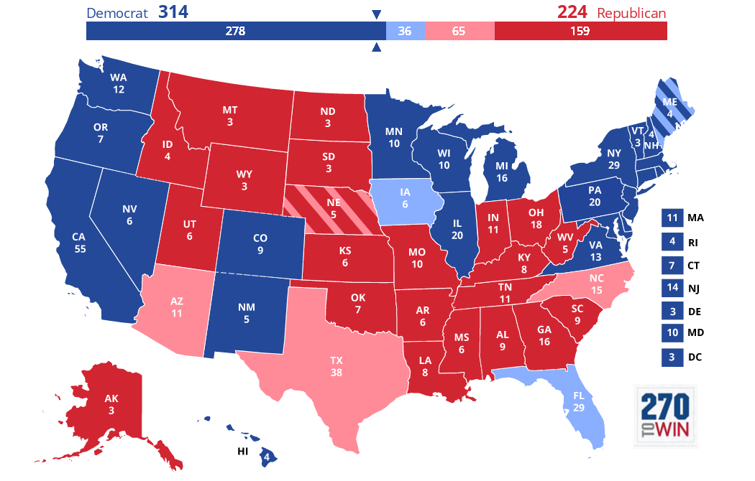

One of the fun (and potentially addicting) things to do prior to a presidential election is to chart out your predicted map on the path to 270 website to see what you think might happen. If the house popular vote were the presidential election, Democrats would have won the electoral college on Tuesday night by taking back the states that were part of the blue wall in the Obama years.

Looking forward to 2020, the best results for Democrats of the night were the victories in Wisconsin, Pennsylvania, and Michigan. Democrats did not lose a senate race or governorship in these states and picked up a few house seats in Michigan and Pennsylvania. Along with this, Trump’s approval rating in these states was underwater. According to CNN exit polls, 55% of voters disapproved of Trump in both Michigan and Pennsylvania and 52% of voters disapproved of Trump in Wisconsin. Given that voter decision was heavily correlated with Trump’s approval rating in the midterms, these results suggest that Democrats could win back the presidency by winning these states. However, in other Midwestern battleground states, there were some ominous signs for Democrats. Trump had an approval rating of over 50% in Ohio, Indiana, and Missouri, which helped Republicans win senate and governorships in those states. This, along, with Republicans winning the governorship in Iowa, suggests that GOP support is still strong among a lot of Trump’s base in these states. Also, as mentioned earlier, it is important to note that 61% of white voters without a degree said they voted for the Republicans in the national generic ballot poll. Given that these voters are overrepresented in the Midwestern battle ground states, the GOP could expect to have an electoral college advantage if they continue to hold the advantage among these voters and win back some of the better educated suburban voters.

The results in Florida, Georgia, and Texas were disappointing for Democrats in 2018; however, they may portend to better results in the future. While all of these three states are still considered red states, it does seem that demographic change may make these states closer in the future. For instance, the fact that the convicted felons are now able to vote in Florida may swing the state slightly more Democratic in future election. These are all states that would make it much harder for Republicans to win if they lose them; however, it is not clear that they will be in play in 2020 given the 2018 electoral loses with relatively strong Democratic candidates. I would also put North Carolina in this category, which has similar demographics and political dynamics to these states in that it could be in play in a good Democratic year.

Lastly, it would be reasonable to argue that the most positive results for Democrats going forward were the senate victories in Arizona and Nevada. These races suggest that Democrats should be able to maintain their advantage in Nevada and make Arizona a near toss up during the next election cycle.

Given all of these results, the map below aims to project what would happen in 2020 if the presidential, election were held against a generic Democrat. This map is essentially the Obama 2012 map in that Democrats would be favored to win every state that he won that year. The only difference I added is that I think Arizona might be toss up given the success of Sinema this year; however, it is would still be too early to project that.

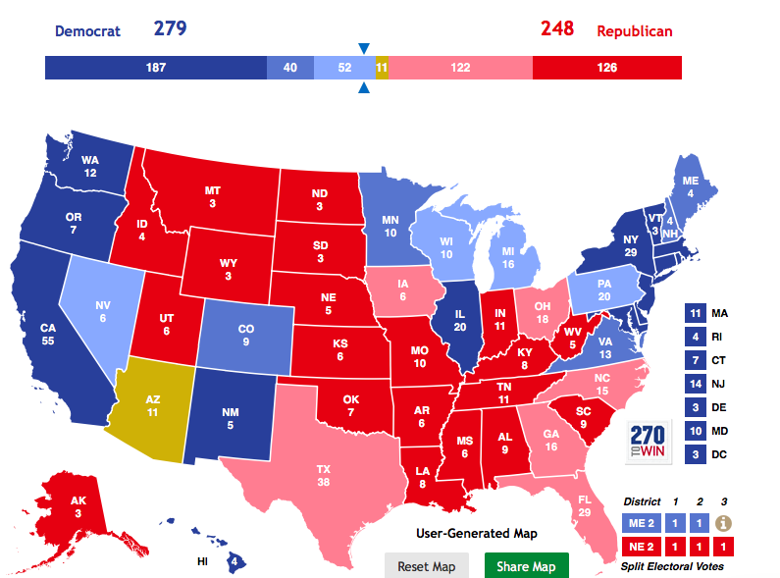

Based on my analysis, I think there are multiple paths to 270 for Democrats; however, some are easier than others. One way to get to 270 is for Democrats to win back Michigan, Wisconsin, and Pennsylvania and hold the rest of the states that Hilary won in 2016. This would likely be the easiest path for them and the most probable path given the 2018 election results. The main reason for this is simply that they won almost all the important statewide races in those states this year, showing their strength in those states despite poor results in 2016. Also, Democrats only lost those states by about 77,000 combined votes in 2016, meaning it would not take that much a shift in the electorate to win back those states.

Another path involves them winning most of the states that Hilary won and trying to win states like Arizona, Florida, Texas, North Carolina, and Georgia. Just winning one or two of these states in 2020 would likely be enough for Democrats to win back the election; however, these states still do lean Republican and would be more difficult to win in 2020.

One of my main theories about the 2020 election is that it will be very hard to find an Obama-like candidate who has a transcendent appeal that will translate to being competitive in every one of the crucial swing states. I believe this because the electorate in those states that has a history of turning out to vote for Democrats is very different. In places like Florida, Texas, North Carolina, and Arizona, Democrats will need to find a candidate who can get minority voters to turn out at high rates while maintaining the 2018 Democratic advantage in the suburbs. In the Midwest, winning involves bringing back some of the traditional base of working-class Democratic voters who broke for Trump in 2016. Given the potentially very diverse and large set of candidates in the 2020 Democratic primary, I will try to evaluate the front runners on their strengths and weaknesses in terms of their ability to win both the primary and the general election. (Note: These are not rankings and the order does not reflect their chances of winning)

1. Elizabeth Warren - I think Warren potentially has a Bernie Sanders type appeal. She is a genuine progressive who has clearly stood up working class people in America. She clearly has expressed the ways that big business takes advantage of working class America, which is a message that could do very well with a lot of working-class voters in the Midwest. I do think she made a blunder by sparring with Trump about her Native American heritage, which she will have to recover from on some level. Lastly, she is very liberal and I do wonder if she will scare a lot of the wealthier suburban voters who just broke towards the Democrats in 2018. Also, given that Bernie Sanders struggled against Clinton with African American and minority voters in the primary, one would have to wonder if this would be a problem for Warren in a general election if she were to win the primary. Also, Warren will be 70 years old in 2020, which could be a factor for voters possibly looking for a younger voice in the party.
2. Joe Biden- Biden should be considered a favorite to win the nomination at this point simply because of his name recognition. He has a history of doing well to motivate working-class voters in the Midwest and will be a prominent voice in the Democratic party. The only problem with Biden is simply his age, which has led many to wonder whether he would want to be president at this point in his life. Personally, I’m skeptical about Biden running given that he did not run in 2016.
3. Kamala Harris- I would classify Harris’s candidacy as very similar to that of Marco Rubio’s in 2016 in the sense that Rubio and Harris were both considered very electable candidates who could come out of the primary and win the general election. They also are both minorities and both senators from large states who are popular among the establishment rank and file. The question will be whether Harris can inspire people in a way that Rubio was unable to. The fact that she is from California will likely help her in the primaries, but I wonder if Republican attacks on another San Francisco liberal woman in the realm of the attacks on Pelosi would hurt her going forward. I think the strength of her candidacy will really be tested in the early stages of the primary to see if she can win over voters who likely don’t know as much about Harris as voters in California.
4. Amy Klobuchar- First, I will admit that I am biased about her because I personally think that she would be a fantastic candidate to pick, even though I have doubts about her getting through the primary. For one, Klobuchar really stood out in a good way in the Kavanaugh hearings by staying on message when Kavanaugh pressed on her own drinking habits. Also, Klobuchar really seems to be emblematic of the nice person from Minnesota who is willing to fight for her voters. I was particularly impressed to learn that she visits every county in Minnesota regardless of whether or not it is an election year, which shows she will fight for her constituents. Moreover, when you look at her results, she was one of the only Democrats who showed the ability to win over voters in rural Minnesota in a dominating win in 2018. Given that Hilary only won the state by 1.5 points, this was an impressive performance. I think her demeanor provides almost a perfect contrast to Trump that could help Democrats win back the Midwest; however, I do question her ability to win the primary given her lack of name recognition. I also think that she could struggle to turn out minorities in states like Florida and Arizona because I am not sure being Minnesota nice is enough to turn out those voters.
5. Beto O’Rourke- It’s hard not to be impressed with Beto’s performance in Texas. Despite some skepticism from pundits and election forecasters, Beto beat his polls and came closer than any Democrat has to winning a Texas statewide election in a generation. Therefore, despite his defeat, this result gave him enough credible momentum to take him seriously as a presidential candidate. To start, the man inspired young and suburban voters in a way that nobody had done in Texas. This led to an extremely high turnout for a midterm election in Texas. Also, it is important to note how well he did marketing himself and raising money. The youtube videos and live streams of him traveling around every county in Texas made headlines and garnered him national attention, which could very well be an effective strategy in the primary. I will caution that he did face off against an unpopular Ted Cruz and that he did not do quite as well in some Southwestern parts of Texas as Hilary did in 2018. I don’t know if we know enough about Beto to say that he would do well in every part of the country; but, we did learn that he is an inspiring campaigner who is clearly a force to be reckoned with going forward
6. Bernie Sanders- Bernie Sanders isn’t polling well for someone who has high name recognition. I think he may not enter the race and endorse Warren. However, he did poll well against Trump in 2016 and is popular among young people. I can’t imagine him actually being president at this age, so I’m skeptical that he will be seriously running with the goal of winning the presidency. I can’t imagine him winning the primaries at this point, especially if he struggles with minority voters again if he runs
7. Kirsten Gillibrand- Kirsten Gillibrand is an intriguing name; however, I worry about the fact that she was the ring leader of forcing Al Franken to resign from the senate. This did not put her in the good graces of the Democratic donor base. This, along with the fact that she was a very moderate congresswoman and now is a very liberal senator (note, she has voted with Republicans less than any Democratic senator during Trump’s presidency). I do think she might have an avenue to popularity among the progressive base, but she has a lot of competition in that role.
8. Cory Booker- Booker has a compelling life story and is a pretty engaging speaker, but I think he has had trouble gaining popularity among a number of Democrats. His ties to wall street and his ties to big pharma made a lot of progressives angry with Booker. He also performed rather poorly in the Kavanuagh hearings. I’m not sure he has the political skills of an Obama type and he has a lot of competition in the primaries. We’ll see how he does in the primaries and on the campaign trail, because I think he’s almost certainly going to run.
9. Other Candidates and beyond: **John Hickenlooper** is a pretty respected governor from Colorado. He good be a decent centrist candidate, but it’s hard to imagine him standing out in the primaries. Michael Bloomberg is an intriguing candidate, but he’s pretty old and I don’t think it helps him that he was a Republican at one point. **Pete Buttegig**, current mayor of South Bend is an intriguing candidate in that he’s a young, openly gay mayor of South Bend who has both lofty degrees (Oxford and Harvard degrees) and military experience. He’s been a very popular mayor in South Bend, but has not emerged on the national stage. He already had a run at the DNC chair position, so he may be someone to keep an eye on in the future. If he can ever win a statewide office in Indiana, he could be an intriguing candidate in the next few election cycles. **Michael Avenatti** should be toast after this recent assault allegation, but he might run. **Richard Ojeda** is slightly intriguing in that he is an old style working class Democrat, but a West Virginia Dem is not going to appeal to a lot of the people who will vote in the Democratic primary. Former governors **Deval Patrick** and **Terry McAuliffe** are exploring runs, but it’s hard to imagine them being competitive. Also, don’t forget about **Sherrod Brown**, who just had a great result in Ohio and has working class Democratic roots. I expect that Dems will want to keep this seat in Ohio and that he won’t run, but he is a potential contender if he runs.